Sinh viên : Vũ Văn Trọng

Mã số sinh viên : 20184206

ASSIGNMENT 4

.eqv KEY_CODE 0xFFFF0004 # ASCII code from keyboard, 1 byte

.eqv KEY_READY 0xFFFF0000 # =1 if has a new keycode ?

# Auto clear after lw

.eqv DISPLAY_CODE 0xFFFF000C # ASCII code to show, 1 byte

.eqv DISPLAY_READY 0xFFFF0008 # =1 if the display has already to do

# Auto clear after sw

.text

li $k0, KEY_CODE

li $k1, KEY_READY

li $s0, DISPLAY_CODE

li $s1, DISPLAY_READY

loop: nop

WaitForKey: lw $t1, 0($k1) # $t1 = [$k1] = KEY_READY

nop

beq $t1, $zero, WaitForKey # if $t1 == 0 then Polling

nop

#-----------------------------------------------------

ReadKey: lw $t0, 0($k0) # $t0 = [$k0] = KEY_CODE

nop

#-----------------------------------------------------

WaitForDis: lw $t2, 0($s1) # $t2 = [$s1] = DISPLAY_READY

nop

beq $t2, $zero, WaitForDis # if $t2 == 0 then Polling

nop

#-----------------------------------------------------

Encrypt: addi $t0, $t0, 1 # change input key

#-----------------------------------------------------

ShowKey: sw $t0, 0($s0) # show key

nop

#-----------------------------------------------------

j loop

nop

* Text Segment:

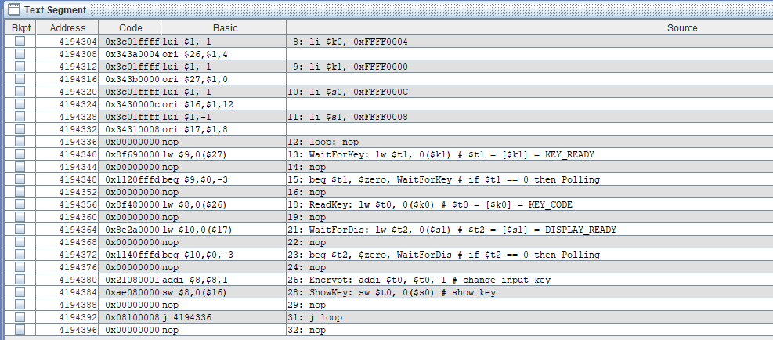

* Kết quả:

